Impact of U.S. Financial Crisis on the European Union

Money Banking and Finance Essay

By – Sarthak Dalmia

ID – 2018B3A70290G

Introduction

The global financial crisis is considered one the most devastating economic shock, second to only the likes of the Great Depression of 1929. In US, the unemployment rose to a peak of 10% in October 2009. The subsequent stock market crash wiped out nearly $8 trillion in value between late 2007 and 2009. With the housing market crash, US households lost about $9.8 trillion in wealth as their house values plummeted and their retirement accounts disappeared.[2] The following graph shows GDP growth rate all across the world over the last 40 years. 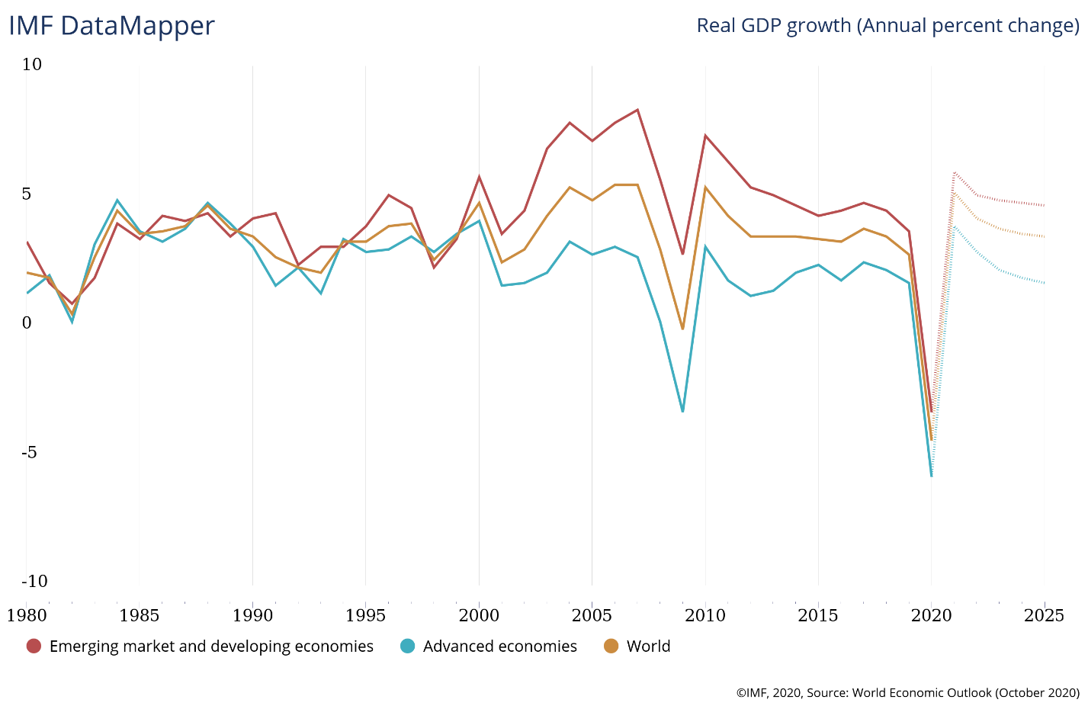 Though the crisis originated in the US its repercussions were felt all over the world. Due to globalization and the increasing position of the US in the global financial system the crisis rippled through the entire world within months of the initial indication of the impending crisis in US. More than $2 trillion in global economic growth, nearly 4%, was lost between the pre-recession peak in Q2 of 2008 and low in Q1 of 2009 according the Moody’s Analytics.[2]

The housing market bubble was forming all over the world over the last decade specially in countries like Ireland and Spain. The bust of the housing bubble in the US led to a cascading affect all over the world. As the value of dollar plummeted with an increased pumping of money from the US government the value of dollar denominated international securities like the Eurodollar bonds also plummeted. Many long-standing banks of the European union like the Northern Rock of UK had suffered huge losses, for support these banks had to ask the national (Bank of England) and international banks for immediate support as lender of last resort. Thus, when the subprime mortgage crisis hit the world those markets restricted their lending from anything over-exposed to the housing markets.[1] Naturally big banks were the first casualty. This triggered bank runs all across the world and a subsequent financial crisis. The bailouts from national banks and the European Central Bank (ECB) were in denomination of hundreds of billions of dollars. Mergers and nationalization of banks were a common sight all across the world.[1]

Some problems with the International Finance Market

International bank is financial entity that offers financial services, such as loans, lending opportunities and payment accounts to foreign clients. These clients can be companies and individuals. These types of banks get there funding mainly from international money market. The international money market consists of various sub-markets such as the foreign exchange market, the international securities market (treasury bills, bonds, equities) and international loans.[3] This increased dependency on international money markets of the international banks as compared to domestic banks (which depend relatively more on customer deposits) make them especially susceptible to changes in foreign currency values and economic conditions of the countries they are invested in. [3]

There are various types of securities dealt worldwide. Foreign bonds are bonds issued in local country in the local currency by a foreign currency. These bonds are regulated by the local market authority.[4] Foreign bonds denominated in US dollars are called Yankee bonds. Another type of bonds is called Eurobonds. These are bonds issued in countries other than the one in which the bond is denominated. Eurodollar bonds are one of the most famous bonds in the International finance market.[4] For example, a German company issuing a bond in US dollars in United Kingdom. This bond can be issued in any country other than US. Eurobonds tradable in the country in which they are denominated are known as Global Bonds. Brady bonds are sovereign debt securities issued by emerging economies backed by US treasury bonds. [4]

Depreciation of dollars results in a decline in the deteriorate balance sheets of banks with dollar bonds. This reduction in assets value reduces the net worth of the bank which leads to various other issues as we already know.[1] Furthermore, going by the balance of payments theory changes trade deficit and surplus affects the exchange rates which results in the above-mentioned problems. Due to the increased scale of the system, there is an increase in asymmetric information. [1] Economic conditions also fluctuates the market a lot. This is due to the fact that the economic conditions of a country and the value of that currency are highly correlated. Expectations of increase in economic growth generally implies inflation and appreciation of local currency.[1] These both factors affect the securities denominated in the currency and the liabilities in bank’s balance sheet.[1] This thus effect the ability of banks to manage liquidity of their assets due to increased or decreased demands of the securities.[1]

How was Europe affected by the crisis?

Different countries in the European Union were affected differently by the financial crisis. Countries like Ireland and Spain already had a housing bubble prior to the crisis. When the housing bubble burst in 2007, default rates on mortgage loans increased rapidly all across the world. This triggered a re-evaluation of asset-backed securities. Due to the decreased demand on asset-backed securities, it created pressure on the banks who issued the loans. The resulted write-offs in banks dealing in mortgage-backed securities and CDOs caused huge losses. This resulted in liquidity crunch in big banks like the Santander Bank in Spain, Northern Rock in England, and many other banks in US. Usually banks with a deficit of funds would borrow from international banks but the liquidity crunch resulted in high interbank lending rates which made it harder to get funds.[1] Additional factor in Spain, was the lack of specific rules and regulation to follow the International Accounting Standards Board standards. This made it easier for banks to hide losses from their balance sheet and thus contributed to the problem of asymmetric information.

Countries like Germany faced a different kind of problem. Germany had mostly constant housing price over the last decade.[5] Germany had the three-pillar banking structure. In this type of structure different types of banks provide different services like mortgage loans, savings accounts etc. This allowed for the first hit of the crisis (namely the defaults on mortgage loans) a much smaller problem compared to some other countries.[5] Only the large international banks and some special banks were victims of stressed liquidity. The insolvency of Lehman Brothers in 2008 resulted in the second wave of the crisis in the Germany.[1] The damaged trust between banks resulted in a greater difficulty in refinancing of a major bank known as the Deutsche Industriebank AG.[1] The SaschenLB bank had reported losses owing to a subsidiary invested heavily in refinancing in asset-backed securities. This position of Germany made the recession period of Germany though deep, relatively short lived.[5]

The special case of Greece

The downfall of Greece was the result of systematic tax-evasion. Wealthier workers under-reported their incomes to avoid taxes.[1] This resulted in huge trade and fiscal deficits. The government of Greece, hoping to revive the economy falsified its budget to meet the Maastricht Treaty conditions (limits government deficits under 3% and public debt under 60% of the GDP) to enter the European Union. Despite the growth in Greece’s economy the government didn’t correct the stem problem of the fiscal deficit.[8] This growth was funded not by tax-payers money but by low rate borrowing from fellow European Union countries. This worsened Greece’s debt position. The global financial crisis exposed the true nature of Greece’s financial situation. The US rating agencies rated Greece bonds to junk in 2010, pushing the country into further liquidity crisis.[1] Greece was forced to ask for bailout from ECB which was conditional on the country undergoing some fiscal reforms. The country finally defaulted in its debt paving the way for the European Sovereign Debt Crisis.[1]

The Case of Northern Rock Bank

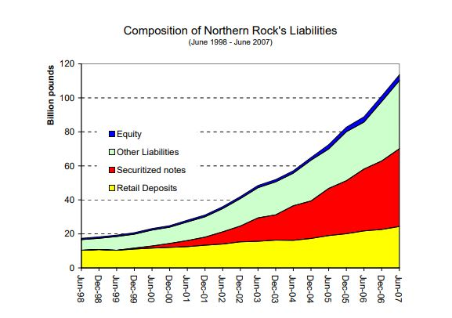Out of all the banks that reported liquidity problems during the crisis in the European Union, Northern Bank of United Kingdom was the first one. During the last decade before the crisis Northern Rock bank expanded aggressively.[1] This was achieved by increased liberalization in terms of regulation in finance markets all over the world.[1] Northern Rock bank had financed most of its growth via international money market instruments such as asset-backed securities.[1] Shadow banking system refers to group of financial intermediaries which creates credit across the global financial system without the use of traditional deposits. They are thus not subject to normal regulation. This played a major role in the credit boom that happened all over the world.[1] Thus, when the housing markets went bust anything overexposed to the housing market was made devoid of funds. The UK’s Special Liquidity Scheme came into effect. The SLS enabled banks to swap high-quality non-liquid bills for the highly liquid UK Treasury bills. These can then be used as collateral by banks to borrow cash.[6] On 14 September 2007, Northern Rock’s perilous position was made public. This triggered the first UK bank run in over 150 years. Northern bank share price fell from all-time high in February of 2007 by 77% by September, 2007. Alistair Darling, the Chancellor, reassured the customers that government will return all existing deposits on 17 September.[6] The method of dealing with bank failure in UK was lack luster in two ways namely: Only GBP2,000 will be reimbursed; and if bank becomes insolvent and put into administration all deposits would be frozen. This aggravated the bank run.[1]

*Source*: <http://citeseerx.ist.psu.edu/viewdoc/download?doi=10.1.1.637.8526&rep=rep1&type=pdf>

*Source: http://www.n-ram.co.uk/~/media/Files/N/NRAM-PLC/results-presentations/halfyearresults080801.pdf*

After support from Bank of England for a few months, Northern Rock was finally nationalized in February 2008. The distrust created by the insolvency of Lehman Brothers made it even harder to get interbank loans. Northern Rock distributed 5% of bank’s profits to good places in the North East prior to the crisis. When the Company Virgin Money acquired Northern Rock in 2012, the headline read: “6,500 jobs created and £175m spent on the social fabric of this region – we should not be deserting them now…”.[7] This call to the public worked and people were lining up to open accounts in the bank rather than closing them. The bank is still going strong with over 3000 employees and re-payments and sale of Northern Rock to Virgin Money would eventually sum up to a profit between £8bn to £11bn in taxpayers’ money.[7]

Conclusion

International finance markets are both a boon and a bane to the global financial health. On one hand it provides huge and easy source of funding thus promoting growth at a level not possible by mere local financing solutions. On the other hand, the high interconnection between various big banks and different economies make the system susceptible to greater fluctuations with variation in any of these components. With the usual interest rate risk, now an additional exchange rate risk is there. Credit crunch in one country, due to some reason, can lead to a cascading effect on other world economies by making it harder for international banks to manage liquidity by interbank loans. As was observed, several long-standing banks like Northern Rock succumbed to liquidity crunch. This happened due to increased dependence on securitized notes and international loans from banks like Lehman Brothers and Morgan Stanley. The global financial crisis has, at its root, the problem of de-regulation of the finance market and the continual decrement of Feds fund rate in the US by the Federal Reserve Bank. This further highlights the problem. Changes in interest rate in one country can lead to a global economic downfall. In the end, according to me, to avoid similar crisis in the future, shadow banking should be more strictly regulated. Large banks should be monitored more aggressively for moral hazard.[1] Private banks should also have strict guidelines regarding the risk structure of the firm’s investment and the liquidity management.[1] The fall of Northern Rock teaches us many things, one of which is diversification of assets in a bank’s balance sheet is not at all a bad idea.[1] After extensive studies regarding the crisis by world’s leading economists, still we cannot be 100% sure on the problems that led up to the crisis. World governments have reformed their financial structures to some extent to avoid future financial crisis but that does not absolve the world of another Global financial crisis in the future.

References and Data Sources

[1] Dalmia, Sarthak (2020): Impact of the U.S. financial crisis on the European Union

[2]<https://www.washingtonpost.com/business/economy/a-guide-to-the-financial-crisis--10-years-later/2018/09/10/114b76ba-af10-11e8-a20b-5f4f84429666_story.html>

[3] <https://money.howstuffworks.com/personal-finance/banking/international-banking.htm#:~:text=An%20international%20bank%20is%20a,lending%20opportunities%2C%20to%20foreign%20clients.&text=Companies%20do%20business%20with%20international,which%20can%20be%20quite%20costly>.

[4] <https://www.investopedia.com/terms/i/internationalbond.asp>

[5]Bleuel, Hans-H. (2009) : The German banking system and the global financial crisis: Causes, developments and policy responses, Düsseldorf Working Papers in Applied Management and Economics, No. 8, Fachhochschule Düsseldorf, Fachbereich Wirtschaft, Düsseldorf, <http://nbn-resolving.de/urn:nbn:de:hbz:due62-opus-5116>

[6] <https://spark.adobe.com/page/DAlRb7HdWiHqA/>

[7] <https://www.chroniclelive.co.uk/business/business-news/northern-rock-anniversary-how-crisis-13614085>